Results Dump

Students

# Sensitizing stage

Number of participants

|  |  |  |
| --- | --- | --- |
| **Postcards** | **School A** | **School B** |
| Welke activiteiten doe jij om te sporten en bewegen | 48 | 35 |
| Wie maakt jou enthousiast om te sporten en bewegen | 25 | 34 |
| Hoe voel jij je tijdens en na sporten en bewegen | 39 | 33 |
| Wat vind jij leuk aan sporten en bewegen | 43 | 33 |
| Waardoor ga jij meer sporten en bewegen | 47 | 34 |

## Welke activiteiten doe jij om te sporten en bewegen?

* Identified top activities
  + Many mentioned walking, cycling, football and martial arts.
  + Some mentioned fitness, PE classes and running.
  + Most did not mention daily activities that also represent a significant source of movement, like their practical lessons and school internships or doing chores at home.
* Many students do these sports/ activities as part of a daily or weekly routine: “I do X Y times per week” “I X everyday”. This relates to the TDF Behavior Regulation.

|  |  |
| --- | --- |
| **Welke activiteiten doe jij om te sport en bewegen)** | **References** |
| walking | 45 |
| cycling | 37 |
| football | 27 |
| martial arts | 17 |
| fitness | 12 |
| PE | 12 |
| running | 11 |
| zwemmen | 6 |
| basketball | 5 |
| cleaning and home chores | 5 |
| werken | 4 |
| horse riding | 3 |
| hockey | 2 |
| dance | 1 |
| dodgeball | 1 |
| jumping | 1 |
| skate | 1 |
| stretching | 1 |
| volleyball | 1 |
| widsurfing | 1 |

## Wie maakt jou enthousiast om te sporten en bewegen

This question related to the TDF Social Influences.

* Many say family (22) and friends (17)
* Some say nobody (8) or only themselves (6)
* A few mentioned sport idols, social media and PE teachers and coaches.

|  |  |
| --- | --- |
| **Wie maakt jou enthousiast om te sporten en bewegen** | **References** |
| family | 22 |
| friends | 17 |
| nobody | 8 |
| myself | 6 |
| sport idols | 5 |
| social media | 3 |
| PE teacher and coach | 2 |

## Hoe voel jij je tijdens en na sporten en bewegen

This relates mostly to the TDF Emotion.

* Many feel tired during and after PA, but it is unclear if they think of it with a good or bad sentiment. Some say they also want to sleep and rest after PA.
* Many feel good, happy and energetic.
* Some mention PA as a positive distraction, with good mental health outcomes. Some say they feel proud of themselves.
* Only 2 responded with a clearly negative sentiment.

|  |  |
| --- | --- |
| **Hoe voel jij je tijdens en na sporten en bewegen** | **References** |
| tired | 38 |
| good, happy and energetic | 35 |
| healthy, fit and sportive | 7 |
| positive distraction | 5 |
| proud and self-efficacy | 3 |
| bad | 2 |

## Wat vind je leuk aan sporten en bewegen

* Many like the expected outcome of PA, e.g., getting fit and stronger. This relates to the TDF Knowledge, TDF Beliefs about Consequences and TDF Goals.
* Many value social relatedness, particularly engaging in PA with friends. This relates to the TDF Social Influences.
* Many mention sports that they like doing and feeling good/ having fun during PA. This relates to the TDF Emotion (also to the major facilitator Fun, expressed by many teachers and experts)
* Again, some mention PA as a positive distraction with good mental health outcomes (e.g., they are busy with something or feeling more relaxed afterwards). This relates to the TDF Emotions and Beliefs about Consequences
* Note that there is only one student that mentions competition and another who mentions challenge.
* Only 4 students respond with an unclear negative sentiment.

|  |  |  |
| --- | --- | --- |
| **Wat vind je leuk aan sporten en bewegen** | **Files** | * **References** |

|  |  |  |
| --- | --- | --- |
| become fit and healthy | 1 | * 21 |
| being outside | 1 | * 2 |
| challenge | 1 | * 1 |
| competition (winning) | 1 | * 1 |
| feeling good and having fun | 1 | * 9 |
| negative | 1 | * 4 |
| positive distractions (busy and impact on mental wellbeing) | 1 | * 3 |
| relatedness | 1 | * 15 |
| rest afterwards | 1 | * 1 |
| sport preference | 1 | * 13 |
| variety | 1 | * 1 |

## Waardoor ga jij meer sporten en bewegen

* Many are motivated because they believe PA has health outcomes and improves their fitness.
* Many are motivated because they enjoy PA and think it is fun, revealing also their sports preference.
* Many are motivated because they can be with their friends.
* This question yielded more negative sentiments.
* Some environmental barriers are revealed: lack of time due to school schedule, lack of financial resources and sports at school.

|  |  |  |
| --- | --- | --- |
| **Waardoor ga jij meer sporten en bewegen** | **0** | * 0 |
| being healthy and fit | 1 | * 17 |
| enjoying it and having fun | 1 | * 12 |
| being with friends | 1 | * 12 |
| sport preferences | 1 | * 12 |
| negative sentiment | 1 | * 9 |
| self-motivation | 1 | * 5 |
| time | 1 | * 4 |
| routines and habits | 1 | * 3 |
| family | 1 | * 3 |
| having a goal | 1 | * 3 |
| being outside | 1 | * 2 |
| social media | 1 | * 2 |
| sports at school | 1 | * 2 |
| positive distraction (being busy) | 1 | * 2 |
| financial resources | 1 | * 2 |
| sport performance | 1 | * 1 |

# Brainstorming Phase

|  |  |  |
| --- | --- | --- |
| **Number of participants** | **School A** | **School B** |
| Class 1 | 9 | 10 |
| Class 2 | 11 | 10 |
| Class 3 | 12 | 11 |
| Class 4 | 12 | 11 |

The data in the brainstorming boards was transformed into **tabular data,** enabling to discover common patterns and quantifying the prevalence of cards and factors influencing PA behavior.

## TDF Knowledge

PA facilitator

***Health and PA Knowledge***

> There is a general understanding that PA improves fitness and leads to positive health outcomes. In the sensitizing phase, many (17) students mentioned the improved fitness and health as motivators to participate in PA. A white envelope with writing on it

PA barrier

***Health and PA Knowledge***

> Low health literacy.

Their health and PA knowledge is limited and at the surface level. It seems that they do not grasp the reasons for the positive health outcomes of PA beyond observable facts (getting fit, having more muscles).

Moreover, it seems that their concept of PA refers exclusively to sports (moderate and vigorous PA), not recognizing daily activities (e.g., cleaning, walking, etc) as PA. They were surprised when their teacher indicated that these activities are also forms of PA, but most failed to indicate them as PA in their timelines.

## TDF Psychological Skills

PA barrier

***Cognitive skills***

> Struggle to understand the health benefits of PA and its concept beyond sports.

Their health and PA knowledge is at the surface level and it seems that they do not grasp the reasons for the positive health outcomes of PA.

## TDF Memory, Attention and Decision Process

PA barrier

***Cognitive tiredness***

> Students struggle to concentrate more later in the day and feel tired after school hours.

This was also evident from the students' behavior during the sessions, when comparing their ability to focus early in the morning and closer to the lunch break.

Many students mention that they are tired after school and want to go home as soon as possible. Many (62) used the “chillen” card after school and in the evening. Students spends large amounts of time at home, not being active, after school hours. In one class, 9/13 students mentioned that they often nap after school for 30 min to 2 hours.

Takeaway: This is a challenging factor to consider in PA interventions: (1) students might need to rest more than the typically developing peers; (2) the threshold to leave the house and engage in PA after school might be higher (as mentioned by the experts).

## TDF Behavioral Regulation

PA barrier

***Breaking habit***

> Lack of early PA habit formation: Adolescents who did not engage in PA early find it changing to break the sedentary lifestyle.

A dislike for sports was expressed by some of these students, who struggled to find reasons to justify this dislike beyond saying “it is boring”. This can also be related to the lack of ‘an early start in sports’, promoted by the social and environmental context, as mentioned by the experts/ teachers.

PA facilitator

**Action Planning**

> Regularly scheduled/ organized activities seems to facilitate participation.

In the sensitizing phase, when asked in what PA forms do students engage, many (15) mentioned that they participate in sports x days per week, indicating that a structured schedule and a habit might decrease the threshold to participation and integrate PA in their weekly routines. This structure was further referenced in conversations in the subsequent sessions. This makes structured and repetitive activities seem appealing for an intervention.

However, it seems that exploration of different sports and forms of PA is also important, as mentioned by the experts.

## TDF Physical Skills

PA facilitator

> Practice and repetition helps adolescents develop physical skills.

Students indicated that they notice improvements in their skills when they do PA more often, especially related to specific sports like football.

## TDF Social Influences

For all groups of people, except the teachers,we observe a **positive trend**, i.e., students tend to think that most people around them help them to be active.

|  |  |  |  |  |  |  |  |
| --- | --- | --- | --- | --- | --- | --- | --- |
|  | **Friends** | **Family** | **Teacher** | **Coach** | **Pet** | **Neighbour** | **Alone** |
| **Nr. of uses** | 76 | 61 | 46 | 24 | 18 | 10 | 29 |
| **Makes it easy** | 51 | 41 | 7 | 18 | 10 | 4 | 14 |
| **Neutral** | 15 | 17 | 17 | 5 | 5 | 2 | 7 |
| **Makes it hard** | 10 | 3 | 22 | 1 | 3 | 4 | 8 |

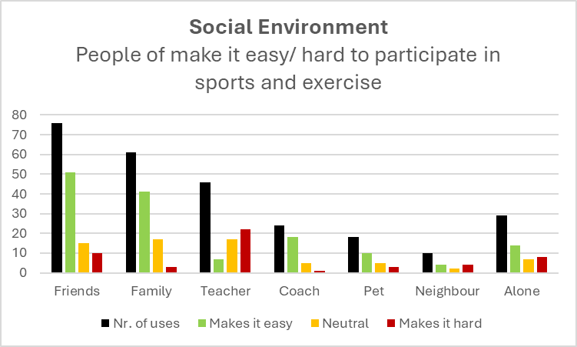

PA barrier

> Lack of social support from teachers (significant barrier)

**Teachers** do not follow the positive trend, being the only group that students think mostly make it harder for them. Similarly, only 2 students mentioned their coaches or PE teacher has people who make them enthusiastic about sports in the sensitizing phase. At this stage, we did not explore the reasons for this perception from students.

**One class with a particularly challenging behavior,** did not use- at all - the teacher card.I noticed that this class did not have a fixed coordinator: multiple teachers were rotating the responsibility for the class. This might lead to a higher feeling of lack of support or even the feeling of absence of a teacher with an important role in their daily routines.

**>** Lack of social support from family

One student mentioned that his **family** failed to sign him up for swimming classes, having missed the deadline. This could mean a lack of social support from the family, but it hints towards what experts mentioned: other priorities are higher that PA in families of a low socioeconomic background. Moreover, it shows that these students might not fully grasp their socioeconomic context.

> Lack of social support in general

In the sensitizing phase, 8 students mentioned that **nobody** makes them enthusiastic about sports.

In the brainstorming phase, many students requested for a card expressing that they are **alone**. This indicates that they spend a lot of time alone, mostly commuting or at home in the afternoon/ evening.

In the **anonymous** notes from students, one (1) student mentioned the lack of belief of others in him regarding PA.

PA facilitators

> Social support from friends

**Friends** were often mentioned in the sensitizing phase as people who make students enthusiastic about PA (17) and as their motivation to participate (12). Friends are mentioned mostly and often as a facilitator to PA in the students’ boards (51/76). *Students want to do sports with their friends. This* idea was expressed spontaneously by many students during the sessions and in additional TDF questions. Moreover, when asked broadly about why they think sports are fun, they quickly mentioned their friends: *“Het is gezellig met vrienden”.*

> Social support from family

**Family** is often (22/ 59) mentioned in the sensitizing phase as people who make students enthusiastic about PA. Family is mostly and often (41/61) mentioned as a facilitator as well in the boards, but not mentioned as often spontaneously in conversations or as their motivation to participate (3).

**🡪 It seems that social support from family and friends is key.**

> Active role models via social media

In the sensitizing phase, **social media influencers** (5) and **athletes** (3) were mentioned as people who make them enthusiastic about sports.

## Physical Environment

|  |  |  |  |  |  |
| --- | --- | --- | --- | --- | --- |
|  | **School** | **Home** | **Outside** | **Gym** | **Sport club** |
| Nr. of uses | 37 | 3 | 15 | 18 | 25 |

PA facilitators

**School**

**>** School contributes to the PA levels of the adolescents, mostly through **PE lessons** and the daily commute. Older students no longer have PE classes at school, which can reduce their PA levels. Only some also mention spontaneous PA during the breaks, e.g. playing football.

> Most students do not acknowledge **practical lessons** as a source of PA, while others say they already move enough during the day without participating in sports. For these students, sports = PA, while activities like walking are not recognized as PA “do not count”. This again relates to TDF Knowledge.

**Outside the school**

> Many students mentioned in the sensitizing phase participating in sports like football (27) and kickboxing (17). In their boards, students mention participating in sports and exercising by going to the gym (18) (unstructured PA) and to sport clubs (25) (structured PA). Some students (15) mentioned engaging in PA spontaneously by going outside with friends and family after school hours. Activities range from just walking around and hanging out, to actually playing sports like football.

**Time**

> Activities that are more flexible than organized sports, like being active outside with friends, going to the gym to do fitness or martial arts seem to be popular.

PA barrier

**School**

> The school period is seen as sedentary, only a few students report being active during the breaks.

> Organized activities by the school were not mentioned.

**PA at home** is very rare. Only 3 students mentioned light PA related to daily life, e.g. cleaning the house. This might mean that few students acknowledge light PA related to daily life as PA. Moreover, this aligns with the idea of an expert: exercising at home is rare for these students (e.g., doing a home workout alone). Actually, as students arrive home, it is likely that they will remain sedentary for the rest of the day (e.g., watching TV, gaming, scrolling), due to cognitive tiredness, unless they participate in organized sports in the evening. This hints at the idea of the ‘threshold’ that experts mentioned of leaving the house to participate in PA after arriving home from school.

**Financial resources of the family**

> Lack of money to participate in sports is mentioned by a few students in the sensitizing (3) and in brainstorming (2) phases, mostly in anonymous opportunities.

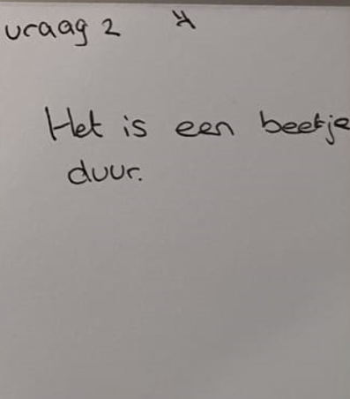

**Time**

> After a tiring school day, adolescents appreciate having their own leisure time and prefer to relax rather than engage in PA. Many students mention that they are tired after school or simply want to go home as soon as possible. Many (62) used the “chillen” card after school and in the evening, most not recognizing it as an active period associating it with rest or sedentary activities (e.g., gaming, being on the phone, watching series).

> The schedule of organized sports might be too rigid for adolescents who prefer flexibility.

> Older students (14) mentioned work, as part time jobs that take their time away from sports.

## TDF Reinforcement

PA facilitators

> Students seem to have a stronger desire for deciding what to do in their own time (related to autonomy and self-determination). When asked what they do after school, they expressed a desire to do what they want of their leisure time.

## TDF Emotion

PA facilitators

In the sensitizing phase:

When asked how do they feel during and after sports and exercise:

* Many students (38) mentioned that feel tired during and after PA, but it is unclear if they think of it with a positive/ negative sentiment. Some say they also want to sleep and rest after PA.
* Many students (35) mention feeling good, happy and energetic.
* Some student (5) mention PA as a positive distraction, with good mental health outcomes.

In the brainstorming phase,

* Many students (19) reported feeling good, happy and healthy through PA.

PA barriers

In the sensitizing phase:

When asked how do they feel during and after sports and exercise:

* Only 2 responded with a clearly negative sentiment.

In the brainstorming phase,

* Only 5 students responded with a clearly negative sentiment about the way they feel during and after PA.

## TDF Social Role and Identity

PA facilitators

For many students, a particular sport is part of their identity, mostly either football or kickboxing.

> Many students just replied with the word “football” to every question: what do they do? Football. What makes them enthusiastic? Football. Who make them enthusiastic? Football players.

PA barriers

In the other direction, students who do not see themselves as sporty are less likely to be motivated to start. This was also shown by their interest in participating in this research’ sessions.

## TDF Beliefs about Capabilities

PA facilitators

Self-efficacy: Some students (3) say they feel proud of themselves in participating in PA.

## Intentions

## Goals

PA facilitators

In the sensitizing phase, many students (21) mentioned that it allows them to become fit and healthy. This might indicate a goal. *Does this mean that it is their goal to…*

PA barriers

In the sensitizing phase, when asked what makes them do sport and exercise, only 3 students mentioned their goals and dreams. This indicates that students lack goals related to PA, in the long term.

## Beliefs about Consequences

PA facilitators

In the sensitizing phase, many students (21) also reported that getting fit and healthy is something they like about sports (21).

In their brainstorming boards, some students (10) report believing that PA contributes to improving their body image, mentioning losing weight and having stronger muscles.

PA barriers

If students only associate PA to loosing weight, it might have a negative impact on their enjoyment of doing it.

## Fun

PA facilitators

In the sensitizing phase, when asked what makes them do sport and exercise, many students (12) spontaneously report that they do it because it is fun.

In the brainstorming phase, the word “leuk” is used 19 times to describe sports. Similarly, the word was repeated several teams in conversations during the session as the major reason why they participate in PA.

## Competition

PA facilitators

In the sensitizing phase, competition and winning were mentioned only once as a positive motivator for PA, particularly sports. In the brainstorming phase, it is mentioned 3 times as something that helps them to do more sports.

PA barriers

In the brainstorming phase, losing is mentioned 2 times as something that makes it hard for them to participate in sports. This is related to negative emotions and to maintaining motivation.

***TAKEAWAYS AFTER BRAINSTORMING***

* Prevalent barriers and facilitators to be combined with the factors from literature and experts’/ teachers’ data.
* Students managed to do the assignment, but could only give limited answers to the questions in the last section.
* In conversation, they mostly mention that they like sports because it is something fun and they can be with their friends. I expect ‘fun’ and ‘friends’ to be key facilitators.

**FACTORS INFLUENCING PA**

**Output of Literature, Preconceptions and Brainstorming**

**This list of factors can be mapped to the TDF domains, but is simplified for the students.**

**Individual Round**

* 1. Fitness level: Jouw conditie
  2. Early start in sports and exercise: Waneer je begon met sporten
  3. Knowledge of physical activity (of its health benefits and of the available options to do it): Wat je weet over sport en bewegen
  4. Ability to navigate social dynamics in sports and exercise: Sporten met anderen
  5. Emotions about PA: Hoe je je voelt over sporten en bewegen
  6. Confidence and self-esteem: Jouw zelfvertrouwen
  7. Body image: Hoe je je lichaam ziet
  8. Goals/ becoming better: Jouw doelen
  9. Autonomy: Dingen zelf doen en kiezen
  10. Habits and routines: Jouw dagelijkse gewoontes

**Social Round**

* 1. Friends: Jouw vrienden
  2. Support from parents/ caregivers: Steun van je ouders
  3. Knowledge and beliefs of PA from parents/ caregivers: Wat je ouders weten over bewegen
  4. Teachers and school staff: Jouw leraren
  5. Staff at other sports facilities: Jouw sportcoaches
  6. Role models: Mensen tegen wie ke opkijkt
  7. Social media: Sociale medie
  8. Competition: Wedijveren met anderen

**Environmental Round**

* 1. Popular sports and activities: Populaire sporten
  2. Available fun and gamified options: Leuke sporten en manieren om te bewegen
  3. Time available and competing behaviors and responsibilities (e.g., chilling, gaming, part-time job, internship, active practical lessons during the day): Jouw tijd na school
  4. Tiredness after school: Jouw zin na school
  5. Inclusive sports and exercise options at school during school hours (breaks, PE): Sporten en bewegen op school tijdens schooltijd
  6. Inclusive sports and exercise options at school after school hours: Sporten en bewegen op school na school tijd
  7. Inclusive sports and exercise options outside of school after school hours: Sporten en bewegen buiten school
  8. Distance to sports facilities: Hoe dichtbij sportplekken zijn
  9. Commuting to school: Naar school gaan
  10. Financial resources: Geld voor sporten
  11. Gender-segregation options: Sporten voor jongens en meisjes
  12. Family cultural background: De cultuur van jouw familie

# Structuring Phase

|  |  |  |
| --- | --- | --- |
| **Number of participants** | **School A** | **School B** |
| Class 1 | 9 | 10 |
| Class 2 | 13 | 10 |
| Class 3 | 13 | 11 |
| Class 4 | 10 | 14 |

Students rated all the factors in 3 rounds: individual, social and environmental factors.

After the first 2 classes, I noticed that students were struggling to rate the cards, and misunderstanding how to place the cards on the board. In 1on1 conversations about the factors, their opinions differed from their ratings, which we corrected together. For the sessions with the following classes, I spent more time explaining examples. For this reason, I did the qualitative analysis including/ excluding these first 2 classes.

In the analysis, I converted the smileys to a Likert scale from 1 ‘makes it really difficult’ (barrier) to 7 ‘makes it really easy’ (facilitator).

**Overall results and plot:**

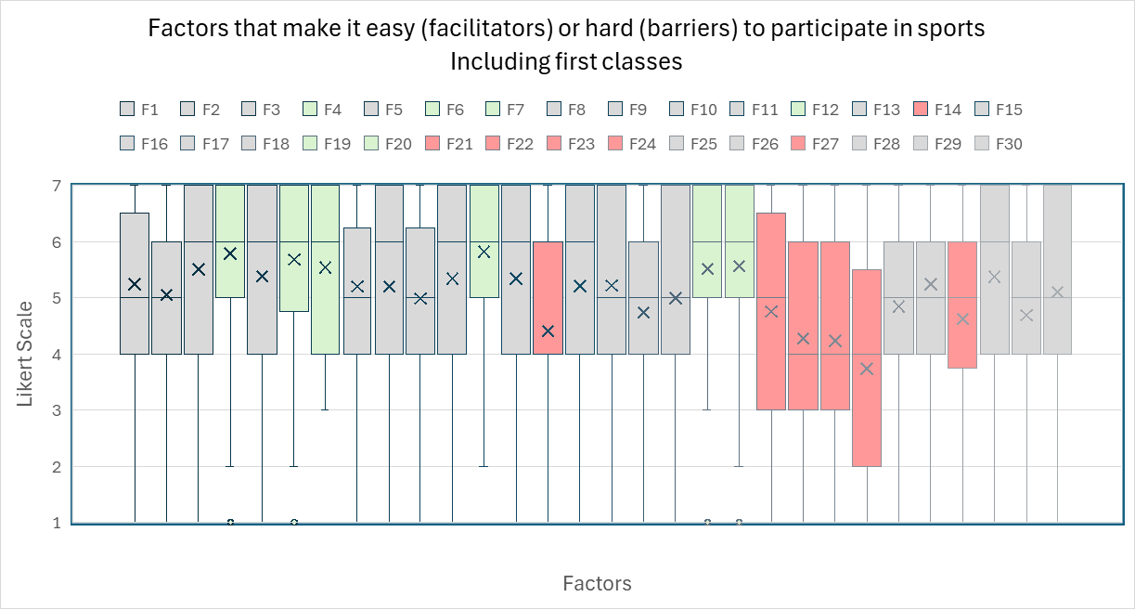

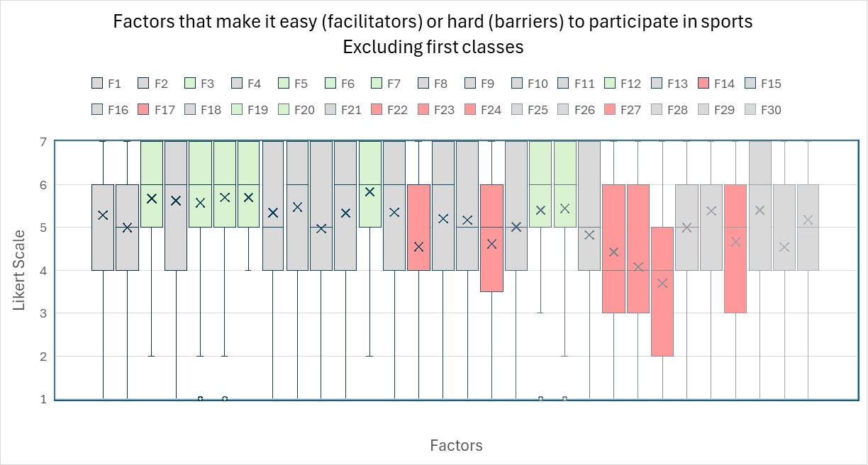

***Analysis***

* There is a **positive tendency** again (similar to rating social influences in the brainstorming phase).
  + Including the first 2 classes, the overall median and average of scores is 5 and 5.07.
  + Excluding the first 2 classes, the overall median and average of scores is 5 and 5.12.
* To remove the positive tendency in identifying barriers and facilitators, we center the results in score=5.
* Barriers: average score < 5 and (median < 5 or Q1 < 4)
* Facilitators: average score > 5, median > 5, Q1 > 4

|  |  |  |
| --- | --- | --- |
|  | **Facilitators** | **Barriers** |
| Including first classes | 4 - Sporten met anderen  6 – Jouw zelfvertrouwen  7 – Hoe je je lichaam ziet  12 – Steun van je ouders  19 – Populaire sporten  20 – Leuke sporten | 14 – jouw leraren  21 – jouw tijd na school  22 – jouw zin na school  23 – Sporten en bewegen op school tijdens schooltijd  24 - Sporten en bewegen op school na school tijd  27 – Naar school |
| Excluding first classes | 3 - Wat je weet over sport en bewegen  5 - Hoe je je voelt over sporten en bewegen  6 – Jouw zelfvertrouwen  7 – Hoe je je lichaam ziet  12 – Steun van je ouders  19 – Populaire sporten  20 – Leuke sporten | 14 – jouw leraren  17 – Sociale medie  22 – jouw zin na school  23 – Sporten en bewegen op school tijdens schooltijd  24 - Sporten en bewegen op school na school tijd  27 – Naar school |

* For the subsequent analysis, we are excluding the 2 classes to avoid wrong results, but the most significant factors do not differ by a lot.
* Facilitators:
  + *Social support from friends(11): It is unexpected that friends do not appear as a big facilitator! Is this because some are negative role models?*
  + Positive feelings (5), fun (20) and popular sports (21) are, as expected, key facilitators.
  + Social support from family (12): Students mentioned that their parents motivate them to be active “with words” while others mentioned that their parents are also participating in PA with them (e.g. ‘my dad goes with me to the gym’). Some also say that their parents take them to sports and watch their matches.
  + Few students mentioned that their parents with a negative sentiment related to sports. One student mentioned that he is mostly alone and does whatever he wants. However, this might also be because the group setup did not allow students to open up about those issues. Overall, I believe that they still see their parents as facilitators because the score would be enough to say otherwise.
  + Knowledge (3) and self-efficacy (6) appear as facilitators, in contrary to what literature, experts, and teachers mentioned. This might be because: (1) students think that having the knowledge and self-confidence indeed helps them to participate in PA, even though they do not have it, or (2) they miss to assess (self-awareness) their levels of knowledge and self-efficacy, not being something they actually perceive as a barrier they face, or (3) they simply did not want to share it in the research setting feeling uncomfortable with it. Anyway, these factors are significant to the students when viewed positively and can be targeted in an intervention, promoting them.
  + Their body image, self-esteem is a facilitator, because many have the goal to have a better body image and fitness level through PA.
* Barriers
  + Barriers seem to be related to school in general. Most have the attitude that school is not cool, they feel tired and want to go home as soon as possible (related to cognitive tiredness). It seems that the majority want to be active mostly outside the school during their own leisure time. Still, some say they are active during the breaks and due to PE.
  + The older ones mention a lack of time due to work.
  + Again, teachers have negative scores. This might be because: (1) they have the chance to give a sad smile to their teachers (typical teen behavior), (2) teachers are only with them during the classes – a sedentary period, (3) teachers are not active role models, as indicated by one of the teachers, (4) teachers do not focus their lessons on sports and exercise (health knowledge), (5) teachers do not know which students are active outside the school (what hobbies they have, as mentioned by some of the students orally), and (5) do not spend time on promoting PA, particular activities or programs.
  + Commuting ended up showing as a barrier, because most students admitted not to do it actively, i.e. they go met de bus or auto or ebike/ fatbike

**Gender results and plot**

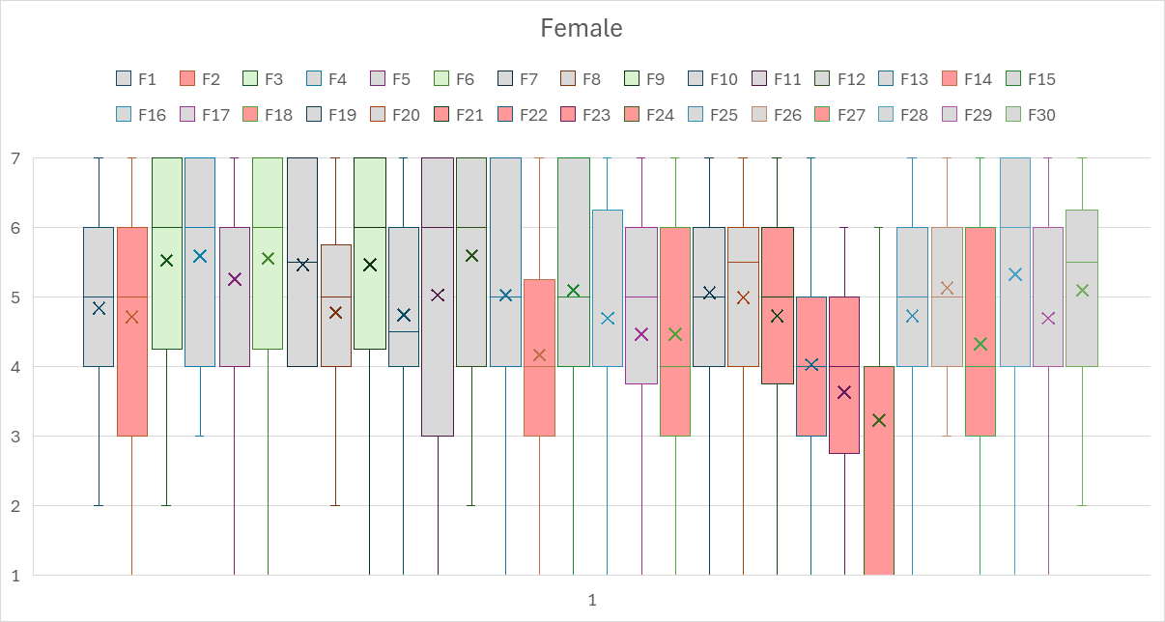

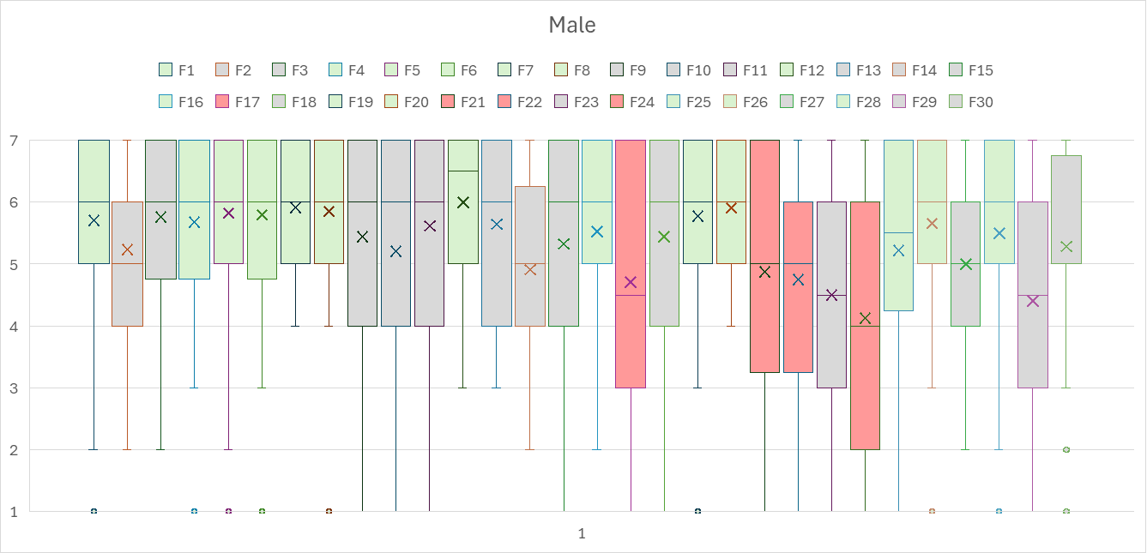

**There is a big gender difference is PA perceptions.**

* The male a female median scores are 6 and 5.
* The male and female average scores are 5.4 and 4.9.
* The positive tendency is shown in both genders, but it is more significant among male students.
* For male students, more factors represent facilitators.
* Only 4 factors are significant barriers to male students: time and motivation after school and activities at school after school hours, and social media.
* For girls, only 3 factors are significant facilitators, not by much: their self-confidence, knowledge and autonomy to choose. Not even fun sports are significant. This is interesting, because girls then might not have available sport options that they like.
* For girls, more factors are significant barriers: an early start in PA, competition, time and motivation after school, and activities at school during the breaks and after school hours, and also the away they commute. This is interesting, because PA is indeed, as an expert mentioned, very tailored to sports competitions. Girls might prefer other activities.

**Questions that require validation:**

Overall, see how **gender** impacts answers.

1. Are sports fun? Is there a gender difference
2. Are the most available sport options fun? Is there a gender difference
3. How are families supporting the students?
4. Are friends actually a key facilitator? Is there a gender difference?
5. Do students really just want to chill after school due to tiredness/ other preferences/ other duties?
6. Do students feel good about their bodies through sports? Are they unsure about the way they look?
7. Are the experts right about a general low self-efficacy?
8. Is the distance to sport facilities a significant barrier?
9. Are teachers providing support? Is there a gender difference?
10. Are spots during the breaks a good opportunity for an intervention?
11. Are sports at school after the hours a good opportunity?
12. How are students commuting? Is there a gender difference?

# Validation

|  |  |  |
| --- | --- | --- |
| **Number of participants** | **School A** | **School B** |
| Class 1 | 9 | 10 |
| Class 2 | 10 | 12 |
| Class 3 | 12 | 12 |
| Class 4 | 9 | 13 |

**Factor: fun**

* Many students find sports fun, but most are male.
* For many girls, but also boys, it depends on the sport
* Key factor combined with available options: attention on how to make sports fun for girls via the available options

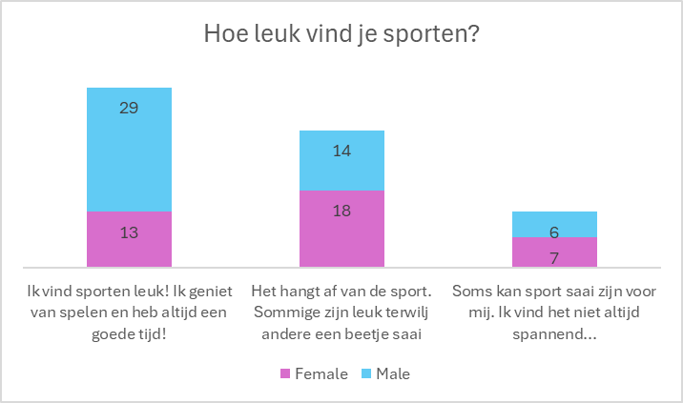

**Factor: available sport options/ popular sports**

* The majority of students (51) enjoys the popular sports (e.g. football), but most are male (33).
* Girls seem to have other preferences
* Key factor combined with fun: attention on how to make sports fun for girls via the available option

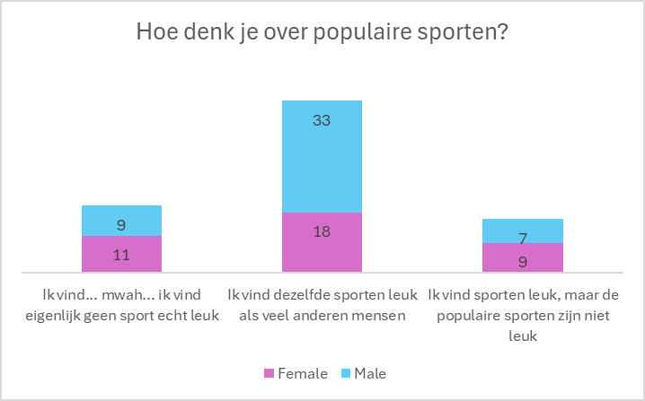

**Factor: social support from family**

* Most students receive emotional and informational support.
* Some students participate in PA with their family, mostly male.
* Few say that they do not receive support.
* *Key factor*

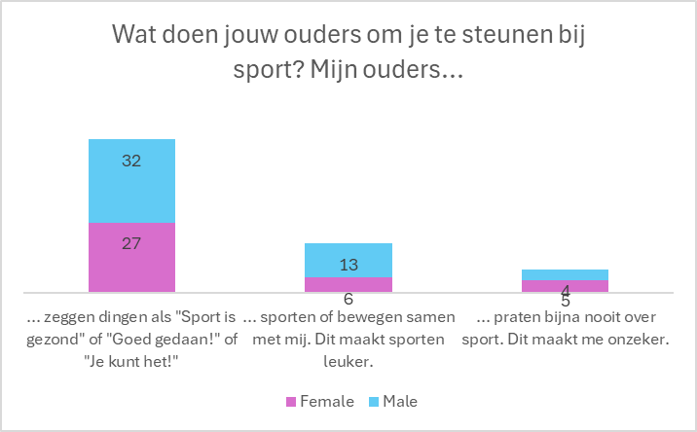

**Factor: social support from friends**

* Most say they enjoy sports with friends, the majority being male.
* It seems that it did not come out as a key factor because girls tend to be less active in their groups, preferring to do other activities. This can be related to social influences, but also to the available PA options and sport culture.
* *Key factor*

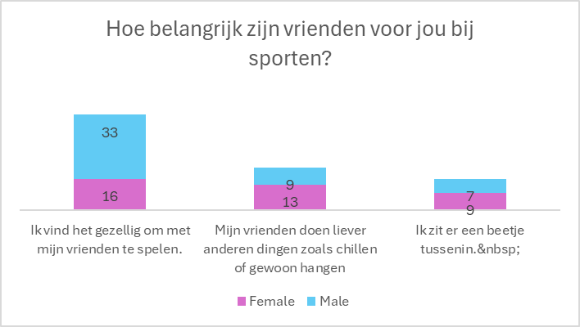

**Factor: time after school + cognitive tiredness + motivation**

* Significant majority wants to rest and do other things, instead of sports.
* Among those who want to do PA and have the time, most are male.

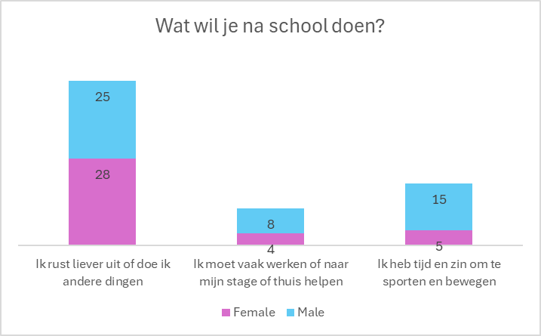

**Factors: self-esteem (related to body image), emotions, goals, and beliefs about consequences**

* Significant majority feels good about their body and want to participate in PA to be fit and look good.
* Was this the correct research setting to report otherwise…?
* *Key factor*

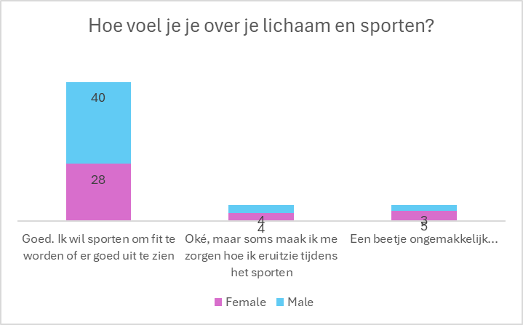

**Factor: self-efficacy**

* Most report confidence.
* This seems opposite to what the experts and teachers report.
* Is this because students are not aware of lack of self-efficacy? Is it because they were not comfortable sharing it in this setting? Is it because they are more confident than the experts perceive them to be?
* Validates that it seems not to be a significant barrier, perceived by the students

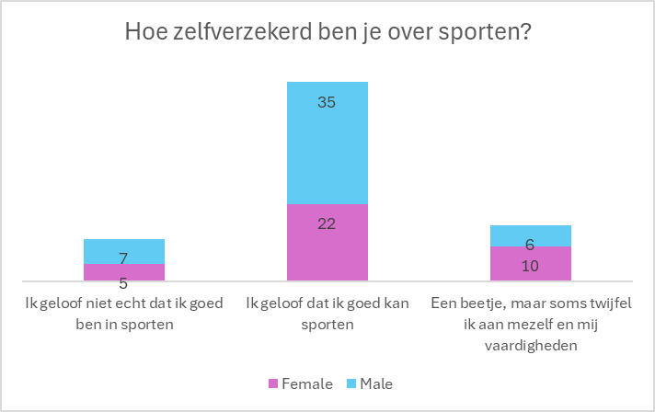

**Factor: proximity of sport facilities/ options**

* Validate that is seems not to be a significant barrier or facilitator.

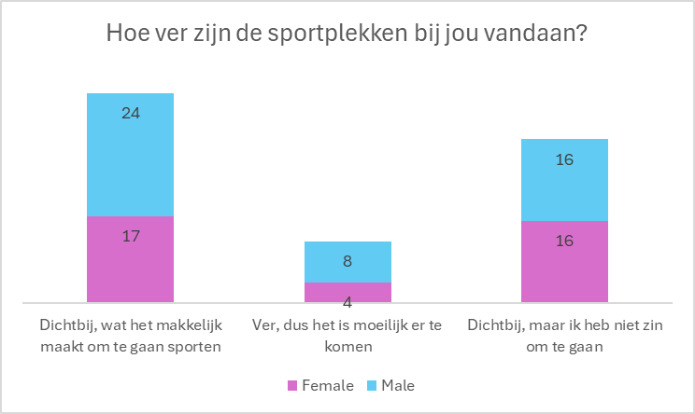

**Factor: social support from the teachers**

* Most students say that that teachers only provide information/ emotional support sometimes or almost never.
* No significant gender difference
* *Key factor*

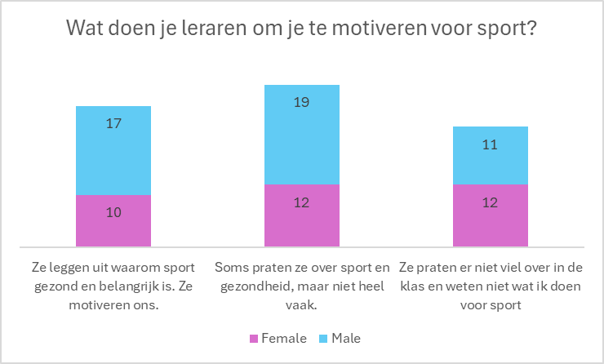

**Factor: motivation, time and resources during school breaks**

* Most students prefer to rest during the breaks, not being active. Students want their own time during the breaks
* Mostly male students are active during the breaks.
* *Key factor. Not an opportunity for an intervention?*

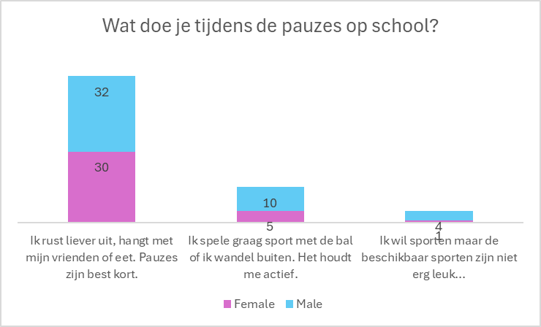

**Factor: motivation, time and resources after school hours at school**

* Most students prefer to leave the school to be elsewhere.
* *Key factor: interventions at school seem not to be the best option*

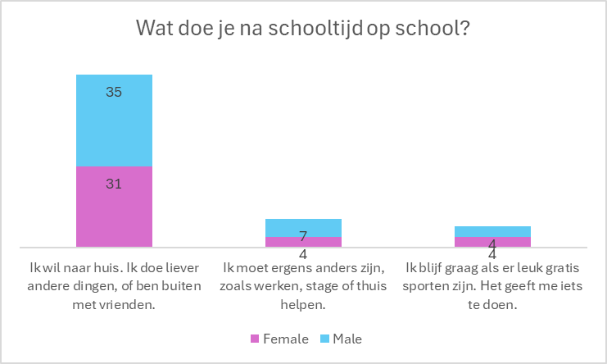

**Factor: commuting**

* It seems that the majority is not commuting actively. Particularly girls.
* Many, mostly boys, have an e-bike missing out on the benefits of commuting actively.
* *Key factor: there seems to be space for improvement here, especially girls!*

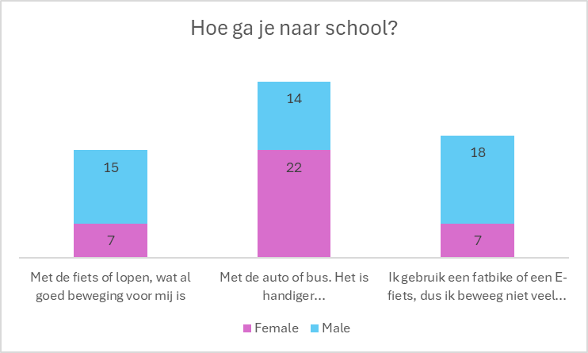

**Takeaways**

* Individual behavior: it seems that these factors influence an individual’s behavior differently. There is not a single unanimous factor, answers are scattered. It seems that personal preferences and context matter and therefore, personalization of interventions matters. Similarly, more complex interventions (i.e., targeting more than 1 of these factors) might be appropriate, as mentioned by experts.
* Gender differences: it seems that some factors are more relevant than others to girls vs boys. For example, it seems that the available sports are more suitable for boys, while girls lack appropriate and fun options.
* The long table of B&F can be updated with more observations, as all factors are relevant to consider in complex interventions.
* Key TDFs and factors influencing PA behavior (a prioritized list of factors) 🡪 relevant domains for the implementation problem of the PA intervention:
  + TDF Memory, Attention, and Decision Process
    - Barrier: cognitive tiredness after school
  + TDF Emotions
    - Facilitator: fun
  + TDF Social Influences
    - Facilitators: friends, family
    - Barriers: teachers
  + TDF Environment
    - Facilitators: commuting non-actively (boy – ebikes), inclusive and fun PA options outside the school
    - Barriers: commuting non-actively (girls), competition-oriented PA (girls)
  + TDF Beliefs about capabilities
    - Facilitator: self-efficacy, self-confidence
  + TDF Goals/ Beliefs about consequences
    - Facilitator: goal of being fit, looking good
    - Barrier: no long term goals
  + TDF Knowledge
    - Facilitator: learning health benefits, learning how to

# Intervention Options

## Define Intervention Functions

|  |  |  |
| --- | --- | --- |
| **TDF** | **Intervention Functions** |  |
| Physical skills | Training | **Train** in physical skills required to participate in PA.  E.g., not removing PE lessons. |
| **Knowledge** | Education | **Educate** to improve health literacy. |
| Psychological skills | Training | **Train** in cognitive and social skills required for PA. |
| Memory, attention, and decision processes  **(cognitive tiredness)** | Training  Environmental restructuring  Enablement | **Restructure the school environment** to promote PA, **enabling** active theory lessons. |
| Behavioral regulation | Education  Training  Modeling  Enablement | **Train** or **enable** the habitual engagement in PA, weakening the desire to rest in the afternoon and evening. |
| Professional/ social role and identity | Education  Persuasion  Modeling | **Educate** to create more positive beliefs about PA. **Enable** short-term wins in PA. |
| **Beliefs about capabilities** | Education  Persuasion  Modeling  Enablement |
| Optimism | Education  Persuasion  Modeling  Enablement |
| **Beliefs about consequences** | Education  Persuasion  Modeling |
| Intentions | Education  Persuasion  Modeling  Coercion  Incentivation | **Educate** and **train** to define action plans and set goals to participate in PA. |
| **Goals** | Education  Persuasion  Incentivation  Coercion  Modeling  Enablement |
| Reinforcement | Training  Incentivization  Coercion  Environmental restructuring | **Persuade**, **incentivize**, **model** or **enable** to feel positive about PA and negatively about a sedentary lifestyle. Promote fun. |
| **Emotion** | Persuasion  Incentivization  Coercion  Modeling  Enablement |
| **Environmental context and resources** | Training  Restriction  Environmental restructuring  Enablement | **Restructure the environment** and **enable** to provide fun and inclusive PA options outside the school environment (not focused on sports performance).  **Restructure the environment** and enable to explore and experiment with different PA options. |
| **Social influences** | Restriction  Environmental restructuring  Modeling  Enablement | **Model** an active lifestyle by teachers.  **Restructure the social environment** to increase support and cultural norms for PA among family and friends. |

Note: the APEASE Criteria should be considered in selection intervention options for a specific context

* Acceptability, Practicability, Effectiveness, Affordability, Side-effects, and Equity

|  |  |
| --- | --- |
| **Candidate intervention functions** | **Does it not meet the APEASE criteria?** |
| Education |  |
| Persuasion | Seems to not be effective. |
| Incentivization |  |
| Coercion | Not acceptable The side effect might be a decrease in positive beliefs/ emotions/ attitudes toward PA. |
| Training |  |
| Restriction | Not effective. Restricting the access to social media did not increase PA at school by much. |
| Environmental restructuring | Yes |
| Modeling | Not accessible for schools, which have a limited staff. |
| Enablement | Yes |

## Identify Policy Categories

For now, we consider that the policy level is not accessible at the research level. We can mimic a change of policy to motivate this change.

## Define Behavior Change Techniques (content and implementation options)

|  |  |
| --- | --- |
| **Intervention Function** | **Frequent/ relevant BCTs** (selected ones) |
| Education | • Information about social and environmental consequences  • Information about health consequences  • Feedback on behaviour  • Feedback on outcome(s) of the behaviour  • Prompts/cues  • Self-monitoring of behaviour |
| Incentivization | • Feedback on behaviour  • Feedback on outcome(s) of behaviour  • Monitoring of behaviour by others without evidence of feedback  •Monitoring outcome of behaviour by others without evidence of feedback  • Self-monitoring of behaviour  •Rewards |
| Training | • Demonstration of the behaviour  • Instruction on how to perform a behaviour  • Feedback on the behaviour  • Feedback on outcome(s) of behaviour  • Self-monitoring of behaviour  • Behavioural practice/rehearsal |
| Environmental restructuring | • Adding objects to the environment  • Prompts/cues  • Restructuring the physical environment |
| Enablement | • Social support (unspecified)  • Social support (practical)  • Goal setting (behaviour)  • Goal setting (outcome)  • Adding objects to the environment  • Problem solving  • Action planning  • Self-monitoring of behaviour  • Restructuring the physical environment  • Review behaviour goal(s)  • Review outcome goal(s) |

# Hints towards Intervention Options

Testing the **attitude** of students towards different behavior change interventions

**BCT: repetition and substitution**

- Behavioral practice/ rehearsal

- Habit formation

**BCT: action planning**

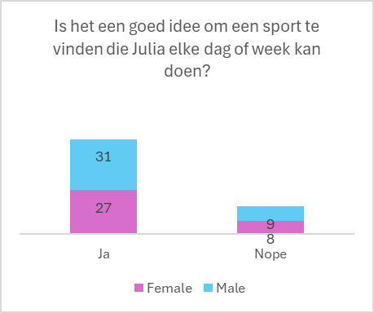

**BCT: Reward and threat**

**BCT: associations (prompts and cues)**

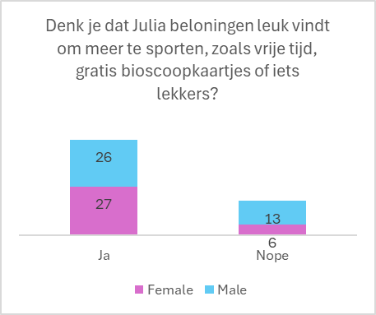

**BCT: Social support**

**BCT: Antecedents (restructuring the social environment)**

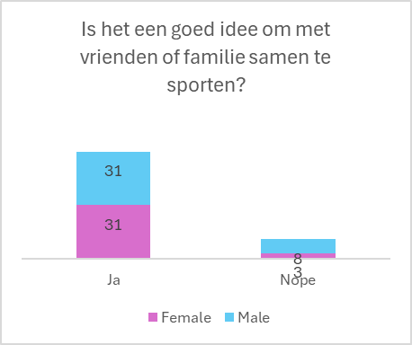

**BCT: Shaping Knowledge**

**BCT: Natural consequences**

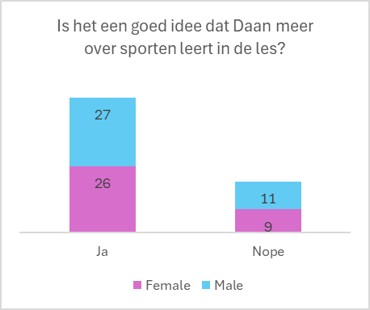

**BCT: Social support (emotional)**

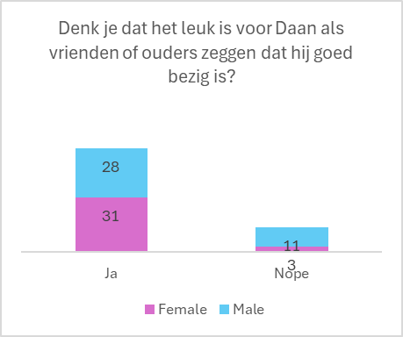

**BCT: Goals and planning**

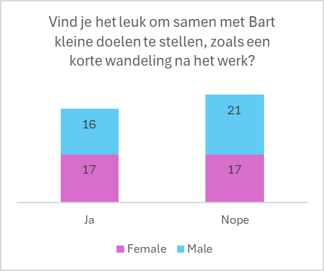

**BCT: feedback and monitoring (Self-monitoring)**

**BCT: associations (prompts and cues)**

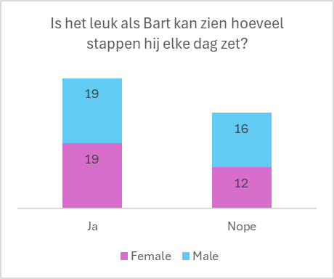

**BCT: feedback and monitoring (feedback on behavior and behavior outcomes)**

